CC 207B Unit 6 Exercise
Name:Joseph Angelo O. Japitana Date: 10/30/2026
Year and Section: BSIT 3-B
Note: Upload your Flutter project to your assigned folder here -> https://github.com/WVSU-BSIT-Batch-2028/CC-207B_26-27_Activities. Read the instructions on submitting, including the file name/folder conventions in the GitHub repository.

I. My Profile App part 2. You will grow the profile app from the Unit 5 exercise. The pet's bark count will survive tab switches, a new Gallery tab will show your photos in a grid, tapping a photo will open it on its own screen and send an answer back, your hobbies will become chips, your class schedule will be a table, and resetting the bark count will ask first. Every part uses a widget from the Unit 6 slides.
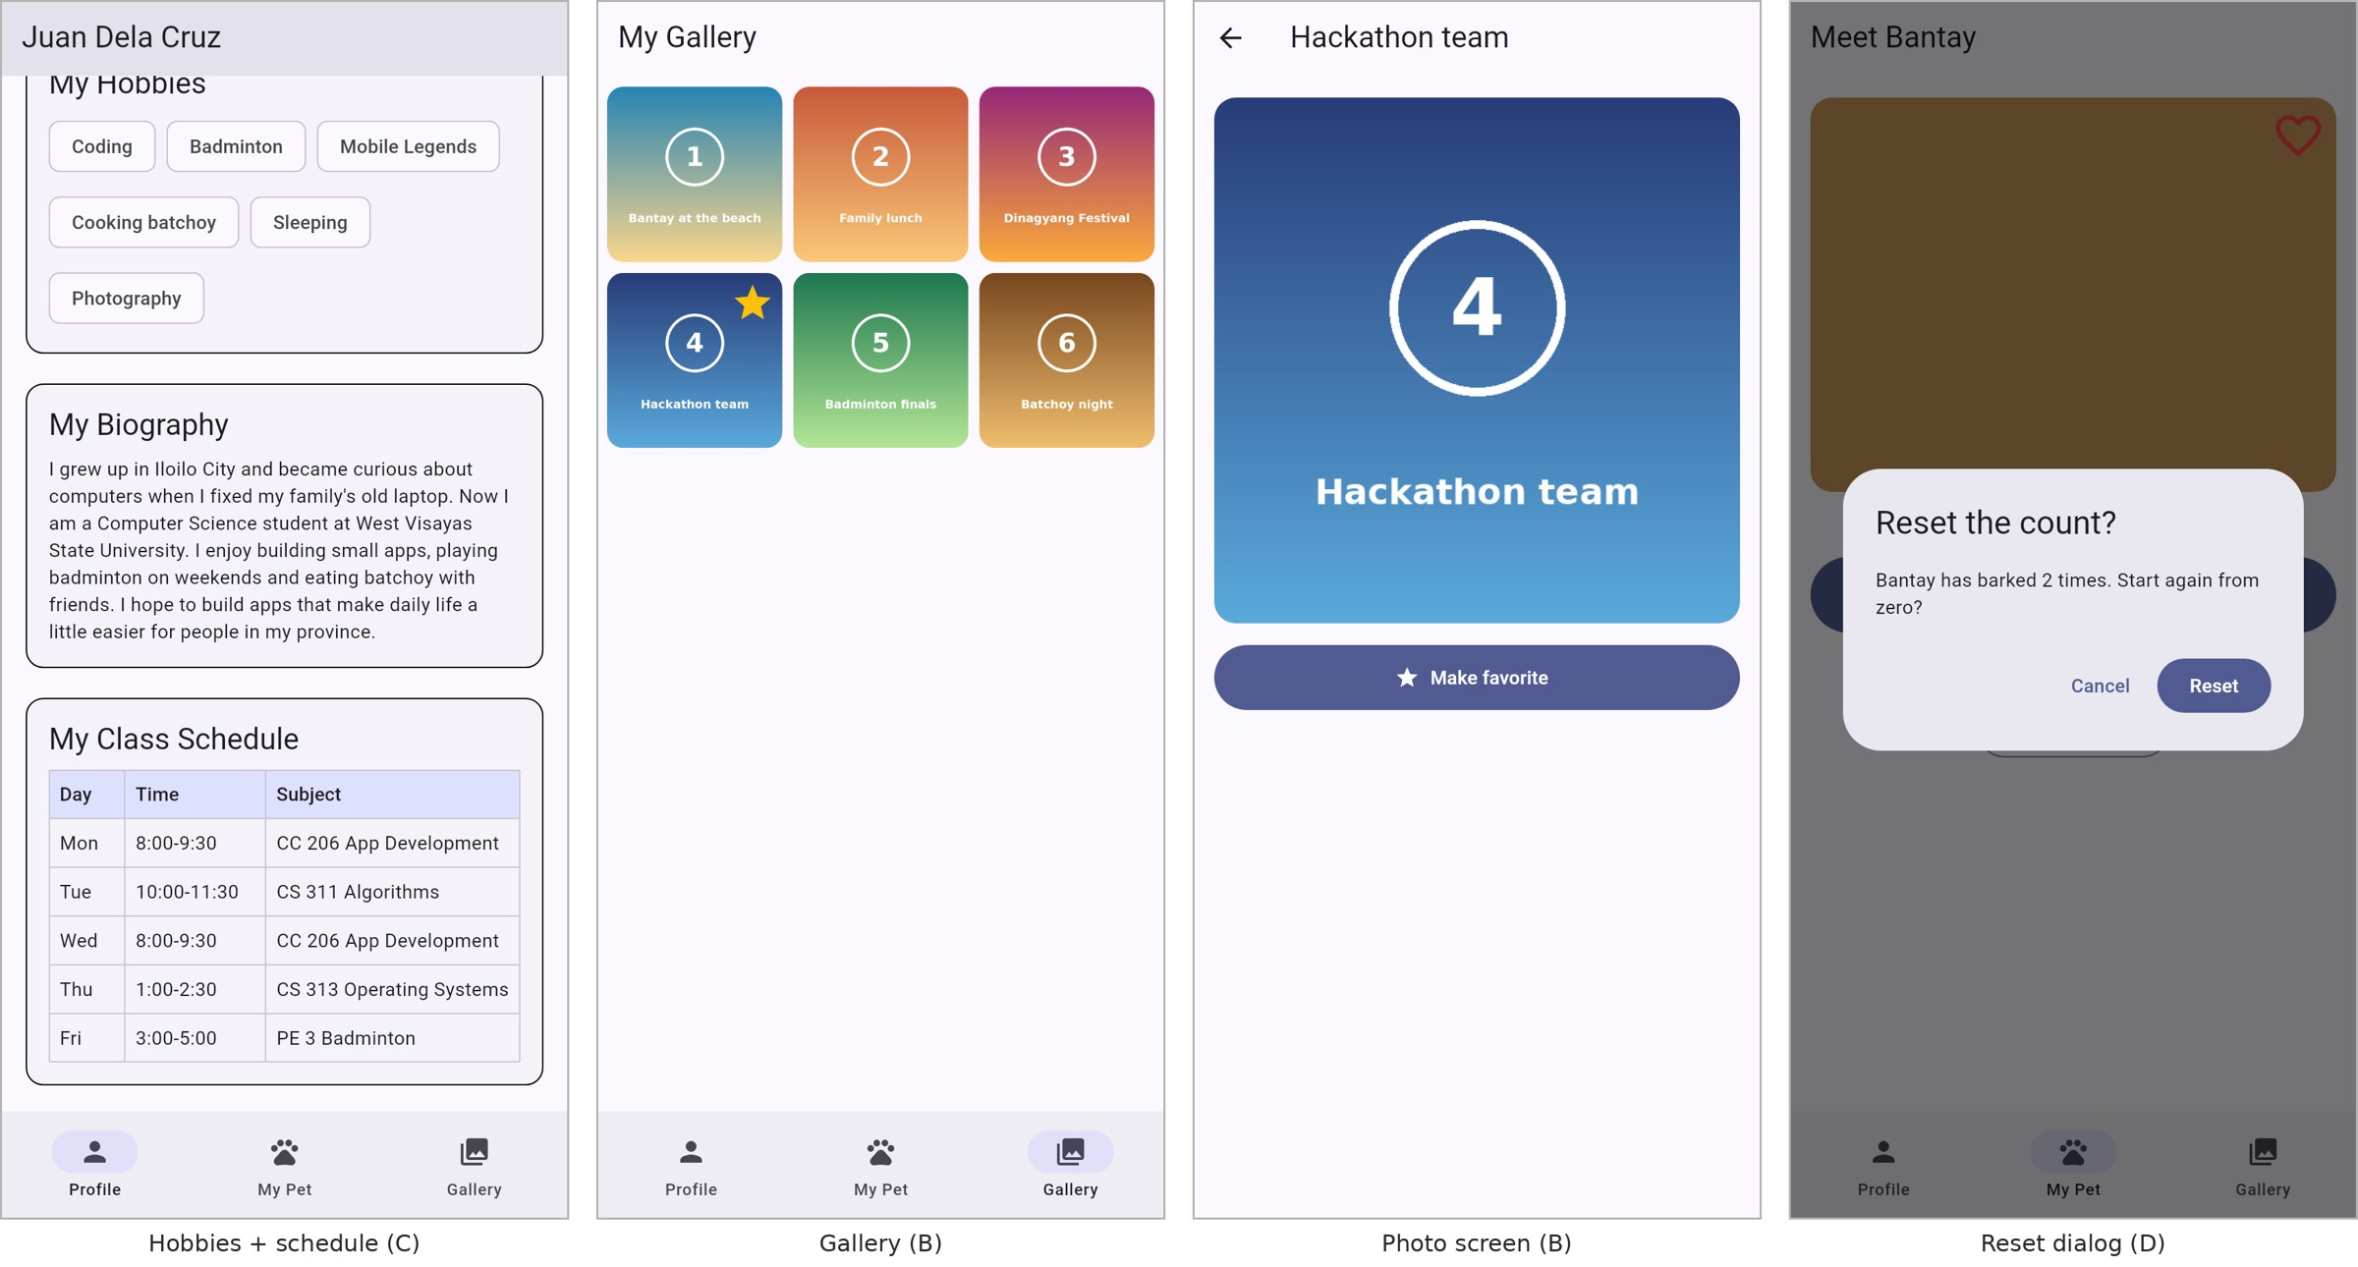
A sample solution. Use your own photos, hobbies and schedule.

Before you start, make sure you have performed the following:
1. Copy your Unit 5 exercise project and rename the copy <lastname>_unit6_exercise (follow the naming convention in the submissions repository).
2. Add at least 6 photos to a new folder assets/images/gallery/ (your own photos, or free ones you have the right to use). Keep them small: under 500 KB each.
3. Declare the new folder in pubspec.yaml, then save (or run flutter pub get):
flutter:
uses-material-design: true
assets:
- assets/images/
- assets/images/gallery/
- assets/sounds/

Part A. Keep every tab alive
a. Tap the play button a few times, switch to Profile and back. The count went back to 0. In HomeShell, replace _screens[_selectedIndex] with an IndexedStack so the count survives.
b. Add a third NavigationDestination, Gallery, with a photo icon, and a third page in the IndexedStack.
Part B. Gallery
a. Write a Photo class with final fields asset and caption and a const constructor. Put at least 6 photos in a List<Photo>.
b. Write a GalleryScreen StatefulWidget with an AppBar and a GridView.extent with maxCrossAxisExtent: 160, spacing of 8 and padding of 8. Build the tiles with a collection-for. Each tile is an Image.asset with BoxFit.cover, rounded corners (ClipRRect) and the caption as its semanticLabel.
c. Tapping a tile pushes a PhotoScreen, passing the photo in through its constructor.
d. PhotoScreen (StatelessWidget): the caption in the AppBar, the photo large, and a FilledButton "Make favorite" that pops back with true.
e. Back on the grid, if the answer is true, save that photo as the favorite with setState. The favorite tile shows a star on top of the photo (Stack and Positioned). Only one photo can be the favorite.
Starting code for the tap (fill in the rest yourself):
Future<void> _open(Photo photo) async {
// push<bool> completes with what PhotoScreen pops:
// true from "Make favorite", null from the back arrow.
final bool? makeFavorite = await Navigator.push<bool>(
context,
MaterialPageRoute(builder: (_) => PhotoScreen(photo: photo)),
);
// TODO: if makeFavorite is true, save photo.asset with setState
}

Part C. Profile additions
a. Hobbies as chips. Take Hobbies out of your information rows. Put at least 5 hobbies in a List<String> and show them in a Card titled "My Hobbies" as Chips inside a Wrap (spacing 8, runSpacing 8).
b. Class schedule. Write a ClassSlot class (day, time, subject) and a list with at least 4 of your classes. Show them in a Card titled "My Class Schedule" as a Table with a border, a header row (Day, Time, Subject) with a background colour from the theme and bold text, and one TableRow per class built with a collection-for. Use columnWidths so Day and Time have fixed widths and Subject takes the rest.
c. The page still scrolls with no overflow stripes on a small phone.
Part D. Reset with a dialog
a. On the pet screen, add an OutlinedButton "Reset count" under the counter. It is disabled while the count is 0.
b. It opens a showDialog<bool> with an AlertDialog: Cancel pops false, Reset pops true. Reset the count only when the answer == true.

Evidences (Screenshot that the application is working):
